KPS Kindy Information Booklet

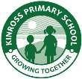KINROSS PRIMARY SCHOOL

An Independent Public School

64 Kinross Drive, Kinross WA 6028

**Phone**: (08) 233 6800

**Email**: [Kinross.PS@education.wa.edu.au](mailto:Kinross.PS@education.wa.edu.au)

**Website**: kinrossps.wa.edu.au

KINDY INFORMATION BOOKLET

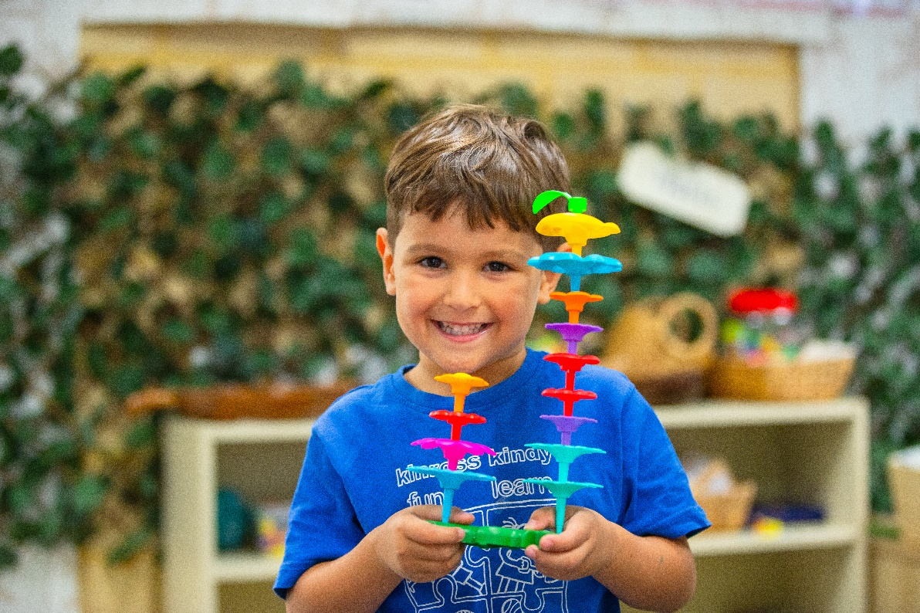

***Our Motto is “Growing Together”***

CARE

COMPASSION

ACCEPTANCE RESPECT

RESILIENCE

EXCELLENCE

**PRINCIPAL’S INTRODUCTION**

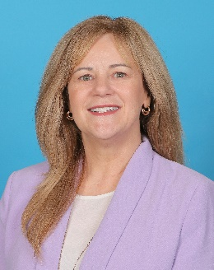

I would like to take this opportunity to welcome your child to our school and you to the school community. This booklet has been prepared as a guide to enable you and your child to feel part of the school as quickly as possible. We hope that the kindergarten school life of all our students will be a rewarding and stimulating experience. We further hope you will support our activities and functions with enthusiasm, and we look forward to working together to provide the best possible learning environment for your child.

Staff at Kinross PS aim to make education exciting, rich and personal for each and every child. We believe that a very important factor affecting your child’s development is the relationship between staff and parents/ caregivers, school and home. All year levels work co-operatively in providing an educational program that will assist each child as they strive to reach their learning potential. We invite you to be our partners in meeting the needs of your children, helping them to acquire new skills for living within a happy, friendly, caring, school environment.

If you have any areas of concern, please contact either your child’s teacher or a member of the leadership team. We

look forward to sharing with you the learning experiences of your child. Yours Sincerely,

Therese Gorton Principal

**OUR MISSION**

To ensure all students have the support and opportunities to develop the skills, knowledge and confidence they need to achieve their individual potential.

**OUR VISION**

At Kinross Primary School we provide an innovative, engaging and inclusive learning environment where we strive for our personal best and excellence in everything we do. We aspire to create collaborative partnerships across the whole school community. The school is committed to providing a safe and supportive learning environment to nurture our students and enable them to build their emotional, social and physical well-being. We aim to inspire a love of learning and provide a quality education that provides a strong foundation for students to adapt continuously in an ever-changing world.

**OUR VALUES**

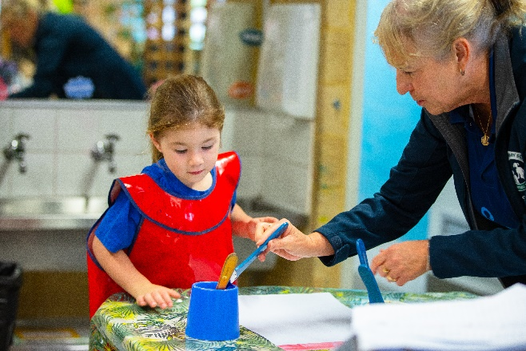At Kinross Primary School we show CARE as we grow together. Our core values include:

* Care and Compassion
* Acceptance and Accountability
* Respect and Resilience
* Excellence and Effort

**OUR BELIEFS**

*We believe that students learn best when:*

* + Teachers are enthusiastic, organised and provide a range of meaningful learning experiences which are developmentally appropriate and focused on intellectual engagement.
  + They have the opportunity to demonstrate their understandings in a variety of ways and assessment directly influences the teaching and learning process.
  + They are provided with the necessary social, emotional and physical training and programs to develop emotional and physical well-being, creativity, personal success and positive relationships. We believe in nurturing the whole child.
  + They learn in a safe, respectful, stimulating and creative environment with clear expectations and boundaries, in which everybody feels safe.
  + Positive partnerships are provided within the school community through collaborative practices and connectedness between home and school.
  + They have instructional leaders who support the success of students, encourage the development of teachers and ensure all decisions made within the school are consistent with and supportive of the school beliefs and vision.

**KINROSS PRIMARY SCHOOL LEADERSHIP TEAM**

|  |  |  |
| --- | --- | --- |
| **PRINCIPAL** | Mrs Therese Gorton | [Therese.Gorton@education.wa.edu.au](mailto:Therese.Gorton@education.wa.edu.au) |
| **ASSOCIATE PRINCIPALS** | Mrs Brioney Smith | [Brioney.Smith@education.wa.edu.au](mailto:Brioney.Smith@education.wa.edu.au) |
|  | Mrs Jill Dodge | Jill.Dodge@education.wa.edu.au |
|  | Mrs Amie Hedges | [Amie.Hedges@education.wa.edu.au](mailto:Amie.Hedges@education.wa.edu.au) |
|  | Ms Bree Short | [Bree.Short@education.wa.edu.au](mailto:Bree.Short@education.wa.edu.au) |
| **MANAGER CORPORATE SERVICES** | Mrs Morag Forrester | [Morag.Forrester@education.wa.edu.au](mailto:Morag.Forrester@education.wa.edu.au) |
| **ADMINISTRATION OFFICERS** | Mrs Mady Hawkins | [Madison.Hawkins@education.wa.edu.au](mailto:Madison.Hawkins@education.wa.edu.au) |
|  | Mrs Michelle Myring | [Michelle.Myring@education.wa.edu.au](mailto:Michelle.Myring@education.wa.edu.au) |

The school leadership team and teaching staff can also be contacted through the school office (9233 6800) or by email (Kinross.PS@education.wa.edu.au)

**SCHOOL BELL TIMES**

|  |  |  |  |
| --- | --- | --- | --- |
| Classroom Doors Open Commencement Recess | 8.30am 8.45am  10.35-10.55am | Lunch Finish | 12.45-1.25pm  2.55pm  (Early Close on Wednesdays- Final  Bell at 2.30pm) |

Kindy students are expected to arrive at school between 8.25 and 8.30am. Students should wait on the verandahs or grassed area in front of their classroom. *Students are not allowed on the playgrounds before and after school.*

|  |  |  |
| --- | --- | --- |
| **KINDY DAYS** | | |
| Kindy 1 | Mrs Jennifer Malone | Monday, Wednesday (odd weeks) and Thursday |
| Kindy 2 | Mrs Jennifer Malone | Tuesday, Wednesday (even weeks) and Friday |
| Kindy 3 | Mrs Caitlin Douglas | Monday, Wednesday (odd weeks) and Thursday |
| Kindy 4 | Mrs Caitlin Douglas | Tuesday, Wednesday (even weeks) and Friday |
| **5 WAYS TO PREPARE YOUR CHILD FOR SCHOOL** | | |

## Physical Preparation is Essential

Before sending your child to school for the first time, it is important to get him/her physically ready to meet the challenges ahead of him/her. A nutritious diet and frequent exercise in early childhood reduces the risk of health problems and lays the foundation for learning in school. Children who eat balanced meals demonstrate better concentration in the classroom. Healthy eating habits, that include fruits and vegetables when your child is two or three years old, will be easier to maintain when he/she reaches school age. Regular exercise encourages fitness and co-ordination. As a child’s body develops activities such as jumping, throwing, catching, climbing, tumbling, and dancing teach large muscle control. Likewise, dexterity and fine motor skills are acquired through activities like colouring, assembling puzzles, working with clay and learning to cut with safety scissors. Practise these skills at home with pre-school-aged children frequently.

## Nurture Social and Emotional Skills

Social skills such as co-operation, sharing, conflict resolution and empathy, help children to get along with classmates. Give your child chances to interact with other children through play dates, classes or trips to the park. Encourage your child to solve conflicts independently and to see the perspectives of others. Emotional skills like confidence, independence, self-control, persistence and motivation are also important for success in school. Give your child the opportunity to make their own choices to build confidence and independence. Use positive reinforcement to encourage persistence and self-control, and motivate your child with incentives for good behaviour rather than just threatening punishment for bad behaviour.

## Language Development and Comprehension Skills Begin at Home

Good language and comprehension skills are developed from birth. There are many ways to engage your child, but talking directly to them can help them learn to speak. Early on, narrating what’s going on around a baby also is helpful. As a child gets older, parents should ask questions that require more than a “yes” or “no” answer. Reading aloud regularly can improve language skills, and discussing what has been read aids comprehension.

## Establish a Daily Routine

Shifting from an unstructured home environment to a school environment can be jarring, particularly for children who did not attend either playgroup or day-care before Kindy. Creating and sticking to a daily routine at home can help you both transition more smoothly. Establish a set time to wake up, get dressed and eat breakfast. Map out daily activities, such as art time, play time, nap time, lunch time and reading time. Getting used to a home schedule will prepare your child for the more regimented school routine.

## Tour the School with Your Child

Visiting the Kindy with your child before the first day may relieve the anxiety she/he feels about entering the new environment. Through the visit, stay positive about the school experience and all the exciting things she/he will get to do. Explain to your child what a teacher does and that the teacher should be treated with respect. The more information your child has about what to expect, the better they will handle the change. An opportunity to meet the teacher will be provided on you Kindy Transition Day.

**Parents show their support for their child’s learning by ……**

* volunteering in classrooms
* exchanging information with teachers
* letting teachers know about home situations that may affect the child’s behaviour at school
* reading to their children daily
* paying attention to materials and notes sent home
* making sure their children are prepared for the day

**WHAT TO BRING TO KINDERGARTEN**

A child’s backpack containing a change of clothes, in case of accidents. The bag needs to be easily managed by the

child and large enough to hold the ‘treasures’ that will come home. Please ensure all bags, clothing and hats are **CLEARLY NAMED**.

* Water bottle, no cordial or juice
* Personal stationery requirements to be brought to Kindy on the first day (labelling and covering is not required)
* Easy to open lunch box and recess in a separate container.
* Wide-brimmed school hat - Labelled

# KEY ADDITIONAL INFORMATION

**ABSENCES**

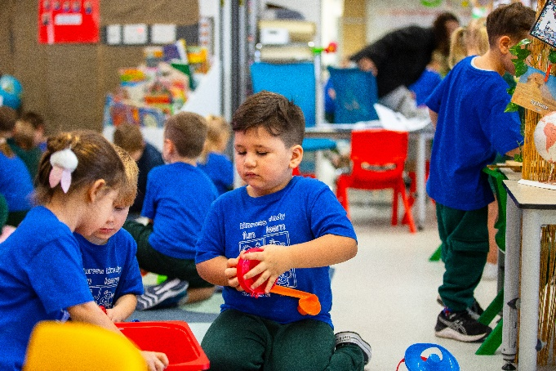Under Department of Education Regulations, the only acceptable reason for absence from school is illness or associated appointments. The explanation for an absence must be received from the parent /carer in advance or the day of the absence and could take the form of an email, a written note, face to face, phone call or SMS school message line on 0408 948 317.

The principal does not have the authority to approve absences for holidays. An absence of this nature is the responsibility of the parent and is viewed as a parent condoned absence and will be recorded as such.

All non-attendance by students will be viewed as critical when it begins to impact on the learning, health and wellbeing outcomes of the student.

Please advise the principal in writing if you will be taking your child out of school for an extended period, or if your child is leaving the school.

Letters are sent out mid-term and end of the term to all families where attendance is below 80%.

**Lateness:** If your child is late for school, kindly report to the front office to get a red late card. This is if your child arrives after 8.40am.

**ACCIDENTS/SICK CHILDREN**

Parents are to ensure that their phone numbers and those of emergency contacts are kept up to date as they will be contacted in the case of an emergency, accident, or sickness at school. It is preferable for children to be aware of those people who are listed as their emergency care, particularly for occasions when they may need to be picked up from school. As facilities at school are very limited in catering for sick children, parents are requested to make a fair judgement on mornings when children genuinely complain of feeling unwell. Those children who are genuinely ill should be kept at home for the health and well-being of themselves and others.

**ALLERGIES/ASTHMA**

If your child has a medical condition (i.e. allergies, asthma) please notify the school immediately if you have not done so already. Where necessary an Action Plan will be developed in consultation with you and the Associate Principal, so that if an emergency arises, directions can be easily followed. This will need to be up-dated each year.

Please note that Kinross Primary School has a NUT AWARENESS policy in place to support students who have nut allergies and we request that children do not bring nut products to school (e.g. peanut paste, nutella, nut bars.).

**BRING SOMETHING FROM SCHOOL TO HOME**

Children may not necessarily “bring something home” each day. Conversation is just as effective as a “material” item. Your child may be quite tired at first and may not want to talk. When parents ask their child “What did you do today?”, the child may answer “Nothing”. However, he/she has been busy developing many skills through play and investigation. Such skills might include spatial awareness, problem solving and co-operative learning.

**CHILDREN’S POSSESSIONS**

The Kindy has a variety of equipment, toys and games for the children to use each day. Children are not allowed to bring toys from home unless they have been requested for a specific reason. Parents, please check with your child’s teacher if you are unsure. Students are not allowed to bring electronic devices from home, including smart watches and jewellery. This is a safety Issue.

**COMMUNICABLE DISEASES**

Students are required to be absent from school for the duration of any infectious period. Health Department regulations on the exclusion from school for specific infections may be obtained from the Department of Health WA website – ww2.health.wa.gov.au. The following infections require children to be excluded:

|  |  |  |  |
| --- | --- | --- | --- |
| Chicken Pox | Influenza | Mumps | Hand Foot & Mouth |
| Ringworm | Rubella S | School sores | Scarlet Fever |
| Conjunctivitis | Measles | Whooping Cough |  |

Measles cases require exclusion of any non-immunised children from school. Immunisation is strongly recommended. Information brochures providing further details are available from the Department of Health WA website – ww2.health.wa.gov.au – or the school office.

Many of the childhood infectious diseases require student/staff to be excluded from day care or school for a recommended period of time; if they are unable to provide evidence of immunisation against specific diseases that are known to be highly transmissible, they will be excluded.

## Colds/Flu and Gastroenteritis

While it is often difficult to prevent the transmission of common respiratory (colds/flu) and gastroenteritis infections that occur, every effort should be made to minimise the spread of infection by encouraging:

* staff and children at school or childcare to stay at home in the early stages of illness as at this stage they can be infectious and shed the virus, bacteria or parasite through coughing, sneezing, contaminating surfaces and personal contact
* school staff and students who are ill should not to return to work/school until they are symptom free if they have a cold or flu and for at least 24 hours if they have had gastroenteritis
* staff and children at day care, healthcare workers and food handlers who have had gastroenteritis should not return to work until they are symptom free for at least 48 hours
* parents to seek medical advice if their child has ongoing symptoms of illness

**COMMUNICATION WITH PARENTS/CARERS**

Effective, accurate and timely communication with our school community is of paramount importance to us. We have prepared a Communication Plan which is available on our website. It outlines our multi-channel approach to communication.

## Whole School

Website – [www.kinrossps.wa.edu.au.](http://www.kinrossps.wa.edu.au/)

Newsletters – published 3 times each term and sent home electronically. Subscribe through the school website.

Connect – reports, attendance, library – log in details and password on enrolment or through the school office.

## Classroom

Connect – class teachers will send out regular updates on activities – log in details and password are available from the office.

Connect Now – download this app to receive Connect notifications.

**CANTEEN**

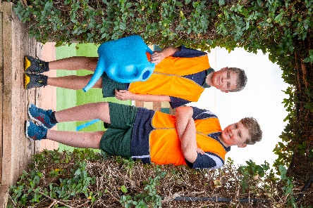Our School Canteen is run by our P&C Committee and is dependent on parent volunteers to keep it running smoothly and efficiently. The canteen runs Tuesday-Friday. A Recess service is available for Years 1 to 6 students via online order or cash at recess time.

Kinross Primary School uses QuickCliq, where parents are able to order online. You can register at the following website address.

[https://quickcliq.com.au](https://quickcliq.com.au/)

The fee for booking an order online is $0.21c per transaction. Parents can view the menu on this website and also is available on the Kinross Primary School website.

**CLASS PLACEMENT**

Class placement is a confidential process undertaken by teachers making the best possible decision for the children in their care.

Kinross Primary School has a very professional and highly experienced staff who access a broad range of appropriate learning programs to address the curriculum and social requirements of all students.

As such, class placements are primarily based on the professional judgment of the child’s educational needs, circumstances and interests by teachers. Issues of gender balance, a range of ability, behaviour, student numbers and the pure administrative needs to form classes are also factors considered in the final composition of classes.

Classes are not to be streamed. No class should have a disproportionate share of high or low achieving children or children with performance related issues. Where children obviously do not get on together, separation should be considered. The child’s social network will be considered if, in the teacher’s opinion, academic performance may be affected.

Consultation with parents will take place in situations where siblings may be in the same class. Parent input regarding their child’s educational needs will be considered, however this will not include requests in relation to the choice of teacher. Parents have the opportunity to make the school aware of their child’s educational needs that may be considered by teachers. This does not guarantee a student being placed in the class of the parent’s choice, rather it adds to the information that is available to staff in making decisions when forming classes. Parents wishing to make such requests should put them in writing to their child’s class teacher when advised that the process is underway.

### The Class Placement Policy is on the school website for your information.

**CONTRIBUTIONS AND CHARGES**

The Education Act (1999) specifies guidelines with regard to school contributions and charges, and a detailed explanation of these is sent to parents separately during Term 4 for the following year. A copy is available on our website throughout the year. The school receives funding from the Department of Education which is used for the basic needs of the school. Further funds to provide extra facilities and resources are provided by the P&C, specific fundraising events, and from parents/carers through the P&C Contribution.

The Education Act allows the school to set a voluntary contribution rate that has been ratified by the School Board. This has been set at $60 per child from Kindergarten to Year 6. School voluntary contributions are used, essentially, to purchase and fund important school resources. Parents/carers are urged to pay their contributions

with the Personal Items list or at the school office as early as possible each year. In case of financial hardship, please do not hesitate to contact the office staff to discuss alternative arrangements. School voluntary contributions can be made via EFT.

Use pay anybody – the recipient is **Kinross Primary School BSB 086 275**

**Account 483571077** - Narration (child's name, room #) - amount.

## Balance of Unallocated Credit

Each student has an account within our Integris system enabling us to bill students for voluntary contributions, Smart Words workbooks, incursions and excursions. With payments being made and receipted for each individual students often we have a credit balance that is unallocated or surplus. When your child leaves the school this surplus can be transferred to a sibling, donated to the school or refunded by EFT into your nominated bank account.

**DELIVERING AND COLLECTING CHILDREN**

Please be prompt when escorting your child to and from Kindy to avoid undue distress. Parents must come to the door at the beginning and end of each session.

On arrival, children are handed over to the care of a staff member and, under no circumstances, are to be left to enter the Kindy classroom alone. Parents are encouraged to spend some time settling their child into the classroom. Children will not be released at pick up time until an authorised adult comes to the classroom door. If an adult is unknown to staff, we will require authorisation from the child’s parents prior to allowing the child’s release.

**DOGS ON SCHOOL GROUNDS**

Dogs are not permitted anywhere on the school grounds, including the oval, at any time for health and safety reasons, even if on a lead. Assistance dogs are exempted.

**ENROLMENT AND TRANSFER**

All enrolments are carried out in the school office. Applications are not complete until proof of residential address (signed lease agreement or utilities bill), Birth Certificate or Extract of Birth Entry, Passport and Visa (if applicable) and immunisation records (ACIR) have been sighted at the school office. Children must be enrolled under their legal surname (ie the name on their birth certificate) or, if changed, the deed poll must be sighted.

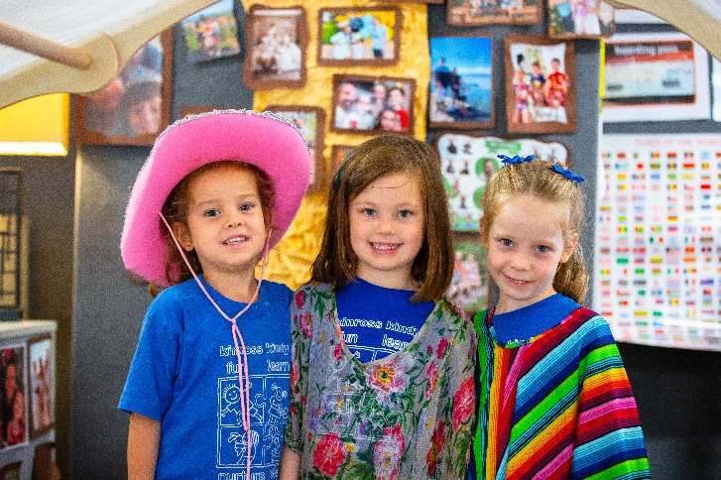

## Leaving the School/Transfers

As soon as it becomes known that you will be leaving our school, please notify the school office of the date on which your child will leave. Early notification allows all outstanding matters to be dealt with, eg:

* Payment of outstanding contributions
* Return of borrowed books
* The collection of personal work books and effects ➢

Refund of any unallocated credit.

The child’s new school (if in WA) will notify us as soon as

enrolment is completed.

## Immunisation

A child's immunisations are expected to be up-to-date upon entry to the school. These include measles, mumps, rubella, polio, whooping cough, diphtheria and tetanus. Immunisations can be obtained through you My Gov account.

**EXCURSIONS/INCURSIONS**

From time to time the school offers a program of excursions and visits of educational interest to support class

programs. These are an important part of a student’s education, and it is hoped that all those who are invited will be able to participate. Transport is usually by bus which must be fully registered, licensed and have seat belts fitted. Full details of excursions will be provided in a note from class teachers.

Please make payments by the due date as given in the excursion note. Refunds can only be made on entry costs where this is possible. Bus costs are calculated on the whole class/group attending and booked in advance; therefore they cannot be refunded.

**FACTIONS**

There are 4 school factions: Bamba (blue) Yonga (green) Karrak (red) Kwenda (yellow)

Students PP-6 are placed in a faction for the purpose of competitive endeavour in various sporting activities. Siblings will be allocated to the same faction. Faction T-shirts can be worn on sport days and are available from our uniform shop. Please note faction shirts are not required until Pre-Primary.

**FIRST SCHOOL MORNING**

For new students who arrive during the year, one of the administration staff will take them to the classroom and introduce the class teacher.

**HEADLICE**

Parents will be advised should their child be found to have head lice during the day. Students may return to school once treatment has occurred and there are no remaining live nits or lice. Preventative weekly shampoos will assist in keeping this problem to a minimum. Successful treatment/prevention can occur by combing conditioner though hair regularly. Information brochures are available from the Department of Health WA website – ww2.health.wa.gov.au – or the school office.

**HOMEWORK**

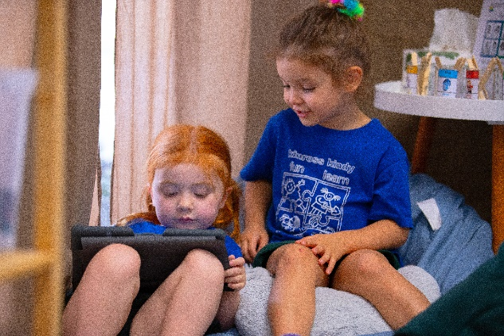

The key value of homework lies in its potential to develop sound home study habits and to reinforce what the student has learnt at school. The school has a policy of regular homework for primary students (PP-Y6). It is the parents/carers responsibility to ensure that the work is completed. A suggested time spent on homework is:

PP-Year 1 5-10 mins

Years 2-3 10-15 mins

Years 4-5 20-30 mins

Year 6 30-40 mins

Homework may be (but not limited to):

* Home reading;
* Set daily or weekly activities;
* Activities not completed in class that can be completed at home; or
* Projects or larger activities with a due date, classroom teachers will provide students with written details about the project requirements and post the information on Connect. If parents/carers require further information or clarification, please contact the class teacher.

**\*NB** Homework should be a regular work time, not a time of challenge. If problems arise, please make contact with

your child’s teacher.

**HYGIENE**

Good personal hygiene is important for the health and well-being of all in the Kinross community. Hand washing with soap and water for at least 15 seconds is expected before preparing or eating food, after using the toilet, after blowing your nose with a tissue and after any contamination of the hands with body fluids such as blood and vomit.

Students are taught personal hygiene as part of the health program. All students are encouraged to be aware of their personal hygiene around others and come to school clean and groomed each day.

**KISS & DRIVE**

A Kiss and Ride facility has been provided at the front of the school on Callander Avenue to assist with the set down and pick up of students. It is important to remember that the driver of the car must be always in the vehicle.

Cars should make their way to top of the queue whenever possible. If your child is not present, you must continue around the block until they arrive.

**LANGUAGE OTHER THAN ENGLISH (LOTE)**

The language taught at Kinross PS is Italian. A weekly lesson is taught to all students in Years 3-6 by a trained specialist language teacher.

**LATE TO SCHOOL**

If students are late to class, parents/carers are to sign them in at the school office.

**LIBRARY KINDY – YEAR 6**

Our Library Officer manages the fully automated Library Resource Centre. Children can borrow one or two books each week (according to year level) if they have a library bag to ensure the books are protected.

Parents/carers are asked to encourage children to return books on time as the cost of replacement of lost or damaged books is passed on to the family concerned. Please encourage your child to become a regular Library user as this will have a big influence on the child’s all-round educational development.

**LOST PROPERTY**

All clothing items found are placed in the lost property containers located IN THE UNDERCOVER AREA. Students and parents are free to check these at any time. Other lost items such as glasses, keys etc. are retained in the office.

Items marked with a student’s name are returned to them. Anything not claimed at the end of each term will be

either sold by the P&C through the second-hand uniform shop or given to a local charity.

There are **many unclaimed items** at the end of each term, so it is important to label your children’s clothes –

especially jumpers, hats, lunch boxes/drink bottles and track pants.

**MEDICATION**

**A request to administer medication to students requires consultation with the school**. For students with medical conditions that require a Medical Action Plan – i.e. asthma, major allergy, regular medication - parents/carers are asked to contact the office so that a plan can be generated. Parents/carers are required to complete the plan and return it to the school office.

No medication will be administered without a Medical Action Plan being completed and medication should not be sent to school with a student or be kept in a student’s bag. For a student who requires medication on a short-term basis, parents/carers should contact the office to complete an Administration of Medication form. · All medication should be provided in properly labelled containers showing the name of the medication, the name of the student and the appropriate dose and frequency. (The means to administer the appropriate accurate dose must also be included).

Medication is kept in the administration area and is administered by the Principal, Associate Principals, or a designated staff member.

**MERIT CERTIFICATES PP-YEAR 6**

Merit Certificates are awarded to students by teachers for a variety of achievements, both academic and nonacademic. The certificates are presented at the fortnightly Friday assembly. Parents/carers are advised when their child is to receive a certificate and are invited to attend and join with the rest of the school in congratulating them.

**MOBILE PHONES**

While it is understandable that some parents provide mobile phones to their children for safety or other reasons, we must protect the safety of all students in our care and maintain good order in our school. Not only is mobile phone use disruptive, using cameras (still and video) to film people and their activities without their knowledge and/or permission is an invasion of privacy and will not be allowed. This applies to other electronic devices which must not be brought to school.

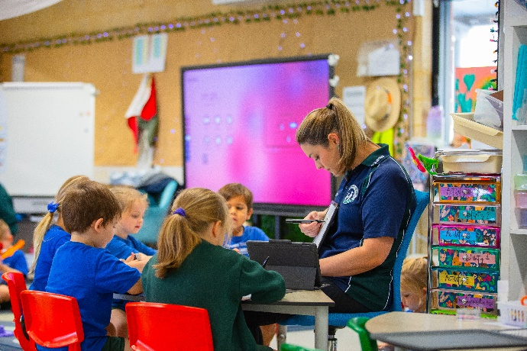Parents who feel that their child should have a mobile phone at school, are firstly required to complete the relevant permission form and then send it into the classroom teacher. Students are then to hand their mobile to the classroom teacher as soon as they ENTER the classroom and collect them at the end of the day. **They must not be removed from their bag while they are waiting before school.** If parents wish to contact their child during the day with an urgent message, it can be left through the school office. Students who do not follow these procedures will have their mobile phone confiscated and parents notified. See **Mobile Phone Policy** on school website.

**MONEY**

All money sent to the school should be in an envelope with the child’s name, room number and what the money is for clearly indicated on the front. Payment can be made direct to the school bank account using the details below. Please quote *Student name, Room, Excursion Name* as the reference.

Account Name - Kinross PS BSB 086-275

Account # 483571077

Students will not be permitted in the sun without wearing an approved school hat and they will be required to remain under the shaded area outside the Kindy rooms.

**NO HAT, NO PLAY**

An approved school hat is required to participate in all Physical Education lessons and sport. Approved school hats are of the bucket type in forest green. Bucket hats are available from our school uniform shop.

**NUT MINIMISATION POLICY**

We have children enrolled throughout the school who have the potential to suffer anaphylaxis. This is a sudden, severe and potentially fatal allergic reaction to VARIOUS FOODS OR SUBSTANCES.

One of the common allergens includes nuts, especially peanuts and nut products. It is important to understand that even trace amounts of nuts can cause anaphylaxis. The sensitivity is such that these children can have a reaction from just touching another child’s hands or sharing toys and equipment with others who have been eating peanuts or nut products. We ask for your cooperation to minimise the risk of these students coming into contact with problem foods by following these simple steps:

* **Please don’t give your children foods containing nuts or peanuts to bring to school.**
* **Be aware many sweets and biscuits contain traces of these nuts or peanuts – eg peanut butter, Nutella, certain muesli bars, chocolate bars and biscuits containing nuts.**
* **Please encourage thorough washing of hands and face with a damp cloth if your child has eaten these foods before coming to school.**
* **Please avoid nuts and peanuts in birthday cakes that may be brought to school.**
* **Please be aware of the dangers of cross contamination.**

If a child has anaphylaxis to a different substance, the classroom teacher will make all parents aware of this and any actions required will be communicated.

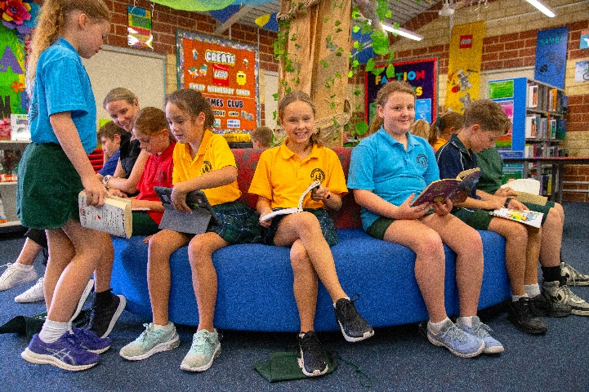

Children have been taught not to share or accept foods from others and this is a school rule. **The school’s main aim is to assist the students in the avoidance of allergies.** Our school Nut Minimisation Policy is in line with the Department of Education Duty of Care Policy and Emergency Response Plans are in place for all activities we conduct. We have, to date, received an excellent level of support from parents and classmates in managing to reduce the risks for these students. We look forward to the same ongoing assistance and understanding on this matter. Further information regarding anaphylaxis can be found at [www.allergyfacts.org.au](http://www.allergyfacts.org.au/) and [www.allergy.org.au.](http://www.allergy.org.au/)

**OFFICE HOURS**

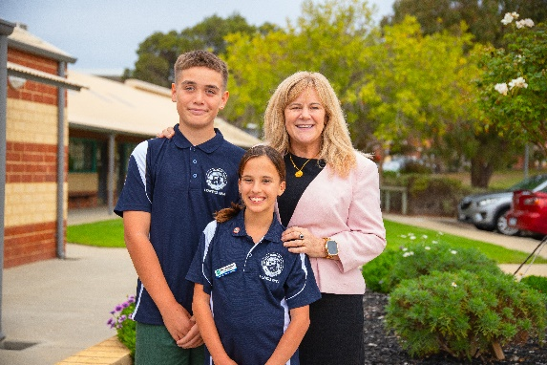

The school office is open Monday to Friday from 8:00am to 3:30pm during the term, except for public holidays.

Please call the school during office hours if you wish to:

* Make an appointment
* Contact your child with an urgent message
* Require information
* Make an enquiry

**P&C ASSOCIATION**

Kinross PS has a strong and active P&C Association. Please become involved and support your P&C. Its functions are to:

* + represent parents/community on school decision-making groups.
  + encourage parents to participate in developing the school’s educational policy.
  + increase parent participation in the school.
  + be the forum for parents to discuss issues pertaining to the school and community for gathering opinion.
  + promote and support communication and cooperation within the school community and to bring educational matters to the attention of the wider community.
  + provide extra amenities for the benefit of students.

*(WACSSO P&C Handbook)*

**PACKED LUNCHES**

A healthy packed lunch box provides children with the sustenance to concentrate and engage in a busy day at school. Fruit is recommended for a quick snack for morning recess. There are many websites with ideas for healthy lunchbox ideas. An icepack in the lunchbox during warmer weather is a good idea. Please be aware of our **Nut Minimisation Policy** and **Healthy Eating Guidelines Policy** (available on the school’s website).

Eating Recess and Lunch at school is a social occasion, sitting with friends. It is also an opportunity to consider how we manage waste – what can be recycled, what can be reused, can we reduce waste? Ensure any containers are manageable by the child and clearly labelled with their name. At Kinross Ps, we have ‘Waste Free Wednesdays’ where we encourage students to not bring food in plastics/wrappers but use reusable containers.

For the first fifteen minutes of the lunch break all students are required to eat their lunch in the designated areas under teacher supervision. Students are not to share lunches or food items for health reasons.

**PARENT INVOLVEMENT**

Parent involvement provides continuity for the child between home and Kindy and therefore parents are encouraged to participate and assist in whatever capacity they are able.

A voluntary roster for parent help during Kindy sessions will be displayed on the notice board. Please write your name against a date that suits you. Grandparents and other family members are also encouraged to help out in Kindy, however they must now hold a valid Working with Children card.

If you have a special skill or talent that you would like to share with the children, e.g. playing a musical instrument or being able to speak another language, please let us know and we can arrange a suitable time and date for you to come in to our Kindy session.

Your child loves you to be involved and in this way, you can be a part of your child’s learning experiences provided in Kindy. Parents on roster are asked to make other arrangements for younger siblings as this is a time for your Kindy child to feel special. Your help is greatly valued.

**PARENT CODE OF CONDUCT**

Kinross PS has developed in conjunction with the Kinross PS Board a Parent Code of Conduct Policy. All parents are requested to read this policy and abide by its principles. This is to ensure we promote a positive environment for all. Parents who display inappropriate behaviour on the school site or through written communication will be contacted by the School Principal and a range of sanctions can be utilised.

**PARENT CONCERNS**

Most school problems can be resolved by making an appointment to discuss them with your child’s teacher. Not only is it a courtesy to always make this your first step in resolving a problem, by doing so you will also be complying with the Disputes and Complaints Policy:

# SCHOOL LEVEL RESOLUTION

Stage 1. *Discussion with staff member* ~ Contact the class teacher or other relevant staff member to discuss your complaint. This is best done by making an appointment via email with the classroom teacher. We will work with you to resolve the problem.

Stage 2. *Review or investigation at the school level ~* Contact the Principal who will work with you and the staff member to resolve the problem. You may wish to formalise your complaint. To do this, you may write to the principal who will acknowledge the complaint with a written reply as soon as possible, even if a resolution is not available at this stage.

### The Complaints Policy can be found on the Kinross PS Website.

**PARKING**

The utmost care is needed when setting down students in the morning and especially when picking them up after school. Wet and very hot weather tends to increase congestion and inconsiderate parking. This in turn increases the risk of an accident. There is a designated carpark for parents of K/P students; however, this does become full quickly. Where possible, walk to school or you may park across the road at the shopping centre if the bays are full.

The school has a Kiss and Ride Zone and marked parking bays at the front of the school. When using these always look out for students. Do not park or stand in the Kiss and Drive zone as it is a flow through zone designed to limit congestion and move traffic in an orderly fashion at the beginning and end of the school day. The school zone has a 40kph limit. There are a number of marked parking bays at the local shopping centre located on Kinross Drive or bordering the school on Kinross Avenue and Callander Avenue**.**

Parents/carers are urged to exercise common sense, patience and consideration for the safety of all students.

**PEAC-PRIMARY EXTENSION AND CHALLENGE**

Primary Extension and Challenge (PEAC) is a centrally supported supplementary part-time program for public school children in Year 5 and Year 6. Children are tested in Year 4 for eligibility although classroom teachers have the final say as to whether children attend PEAC. The school does offer enrichment classes in various learning areas from time to time. At Kinross PS, we are also endeavouring to ensure every child is catered for and we have been participating in professional learning on catering for gifted and talented children within the classroom.

Kinross PS has a PEAC Centre located on the school site. The PEAC Centre is part of the North-Metro Regional Office PEAC service. Children are withdrawn from regular class to attend PEAC programs. Students are identified through the PEAC Testing program in Year 4.

**PERSONAL USE ITEMS (BOOKLISTS)**

Although the Department of Education supplies books and materials for students, some stationery and personal items are the responsibility of parents/carers. At the end of each year students are given a list of requirements for the following year. Parents/carers are encouraged to participate in the school’s bulk order process to ensure that items are of consistent quality and type. Naturally, they are free to purchase the requirements from other sources if

they so choose. Throughout the school year it may be necessary to replenish supplies. Teachers will advise parents/carers when this is necessary. A copy of the Personal Items list can be downloaded from the school website.

**PICK UP DELAYS**

Please advise your child to come to the school office if you do not arrive for a scheduled pick-up at the end of the day. We will then endeavour to phone either the parents/carers or the emergency contact. The school office will make every effort to get a message to students, but we cannot guarantee this, particularly if parents/carers are phoning towards the end of the day.

**PLAY EQUIPMENT**

**For safety reasons, students are not permitted to play on any outdoor playground equipment before or after school as teacher supervision is unavailable in these areas.** This applies to children whose parents may be present, as often unsupervised students will want to join in compromising our duty of care.

**PLAYGROUND DUTY**

An adequate number of staff are rostered on playground duty during recess and lunch to provide supervision of students. Whilst on duty they wear hi-visibility vests so that they easily identified. Students are encouraged to report any problems to the teacher on duty.

**PROTECTIVE BEHAVIOURS**

By teaching protective behaviours with our children, we will be helping to develop lifelong skills of assertiveness, self-confidence, problem solving, communication, resilience and help seeking.

The protective behaviours program is based on two themes:

* + We all have the right to feel safe at all times.
  + We can talk with someone about anything, no matter what it is

Protective Behaviours is a life skills program which teaches students to:

* + Identify and deal with potentially unsafe situations.
  + Develop practical skills to help keep themselves feeling safe.
  + Recognise their own personal early warning signs when they are not feeling safe.
  + Develop a close network of people with whom they can talk to when not feeling safe.
  + Develop assertiveness together with communication, relations, and problem-solving skills.

**READING**

In accordance with the Department of Education the main emphasis in Kindy is on “social, emotional and physical well- being”. The programs provided for your children focus on building oral language and pre-reading skills. We encourage parents to read to children and access books from the local and school library. READ BOOKS TO YOUR CHILD AS OFTEN AS POSSIBLE.

Students, staff and parents of Kinross Primary School are served by an up-to-date, state of the art library and resource centre. The library is accessible 5 days a week during school hours to all students. (Library sessions are conducted weekly by the Teacher Librarian for each class, year 1 to 6). Book fairs are a feature throughout the year.

**REPORTING TO PARENTS**

The school uses a reporting system that is both informative and helpful to parents/carers. This involves a

combination of the Department of Education’s formal online reports, an open night and parent meeting at the

beginning of each year. Two formal reports are provided each year electronically through email - one at the end of each semester.

By far the best method of reporting to parents is through face-to-face discussion. This can be done by contacting the office or the teacher directly to make an appointment for an interview. Parents/Carers are urged to make personal informal contact with their child’s teacher regularly during the year, and especially if there is a problem of any kind. Alternatively, teachers will contact parents/carers if they wish to discuss a student’s progress.

**SCHOOL BOARD**

Independent Public Schools (IPS) are required to have an effective school board that includes parent/carer and community representation.

The principal is responsible for the educational leadership and operational management of the school. To maximise the input of the school board in developing policies, the principal seeks advice and receives recommendations from the board.

The Kinross Primary School Board consists of the following: Principal, two elected teaching staff representatives, four elected parent/carer representatives, and up to two community representatives appointed by the board.

The Board is formally accountable to the Minister for Education, and its functions include:

* + Establishing, and reviewing the school Business Plan.
  + The planning of financial arrangements necessary to fund the Business Plan.
  + Evaluating the school’s performance in achieving targets set in the Business Plan.
  + Approval of a Code of Conduct i.e., Discipline Policy.
  + Determining a Dress Code for the School
  + Marketing
  + Determination of fees and charges
  + Determining sponsorship and advertising

The Board is strictly focused on strategic functioning of the school not the daily operational functions.

**SCHOOL CHAPLAIN**

Kinross Primary School has a Chaplain, Di Sanders, who works at the school three days each week on a Monday, Wednesday and Thursday. Di is an important part of our pastoral program and is available to support students, parents and teachers in the following roles:

|  |  |
| --- | --- |
| ***Social:*** | The Chaplain offers strategic support and training to develop leadership and  citizenship skills for groups of students. |
| ***Emotional:*** | Provide pastoral care through conversations with individuals and groups experiencing personal or social difficulties, enabling them to work through their difficulties and adjust to change. |
| ***Spiritual:*** | Help students to formulate their own beliefs and value systems and work with  staff to incorporate aspects of the core values into the school’s programs. |

***Mental:*** Offer self-esteem and social skill enhancing programs for specific groups of students, enabling them to participate more confidently and effectively.

**SCHOOL GROUNDS**

After school hours, during weekends and on school holidays, no person is permitted on the school property without prior permission from the principal. The principal, members of staff and Department of Education security officers, have the right to request people to leave the school grounds. Failure to comply could result in a prosecution for trespassing. **Parents/carers are asked to ensure that students do not come on to the school grounds out of hours.** The school oval is exempted.

**SCHOOL NURSE**

The school is serviced by nurses from Health Department. A School Nurse is available for routine testing and to conduct health assessments of Pre-primary and Kindergarten students.

**SCHOOL PSYCHOLOGIST**

A school psychologist is available for consultation. The psychologist’s role is to assist students who would benefit from academic, behavioural or emotional support. Parents/carers may refer their child to the school psychologist by making contact with their child’s teacher or contacting the Students at Educational Risk (SAER) manager via the front office. After consultation with the Learning Support Team, a meeting may be called to decide what sort of support is required.

The Department of Education has Educational Support Units/Centres and Language Development Centres for students with significant learning or language difficulties or disabilities. The school psychologist recommends such students for placement in these centres. Students with lesser challenges are catered for within the regular classroom.

**SCHOOL PHOTOS**

All students are photographed by our nominated school photography company. No-obligation package deals are sent home to parents/carers at the appropriate time.

**SPECIAL PROGRAMMES PP – YEAR 6**

Our school has Specialist Teachers in Visual Arts, Music, Physical Education, Health and Italian.

**UNIFORMS**



clearly marked with the child’s name and room number

All students are expected to meet dress requirements. From the time of enrolment, parents are asked to take responsibility for outfitting their children according to the requirements of the Kinross PS Uniform Policy. This is available on the school website.

Uniforms are sold from the uniform shop located in the undercover area. It is a good idea to buy uniform items before school commences, so that new students feel part of the school from their first day.

The cost of new school uniform items is kept to a minimum. We strongly recommend that all items are

**WEBSITE**

The school has an amazing and informative website that you can easily access, just Google Kinross Primary School and have a look at what our school has to offer and the many activities that the students undertake throughout the year.

<https://www.kinrossps.wa.edu.au/>

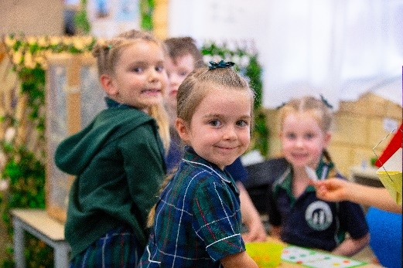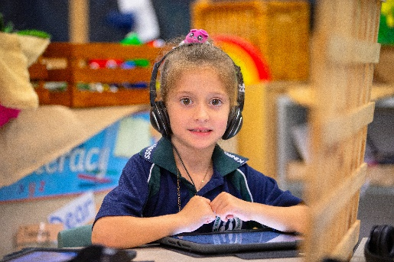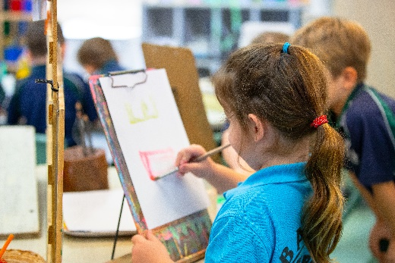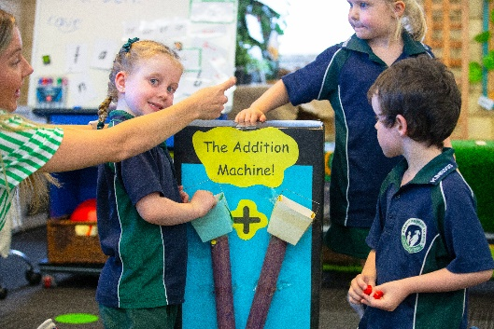





*This is our school, it’s up to you, We work and grow together. This is our song, so sing along, We work and grow together.*

In our community, We live in harmony,

The best that we can be.

You can do it!

Red, blue, gold and green, No matter what our team,

We can achieve our dreams.

You can do it!

**Kinross Community, We live in harmony,**

**The best that we can be.**

**You can do it!**

*This is our school, it’s up to you, We work and grow together. This is our song, so sing along, We work and grow together.*

We come from many lands, Together we will stand, Come on and take my hand, Grow together……

Grow together, now!